CURRICULUM VITAE

Mr.Chiragkumar Pravinchandra Gohil
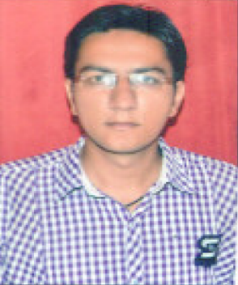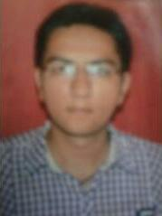
M.B.A. Marketing
Email :- cgohil62@gmail.com
Contact No :- (M) +91 9909384706

ADDRESS:
Nilkanth Bhawan,
Swaminarayan Mandir
Near Zadeshwar Bus-Stand,
Bharuch.
Pin-392001
GUJARAT

CAREER OBJECTIVE

To seek challenging avenues where my knowledge and experience matches with the organization's growth. Looking for an opportunity to obtain Sales or Marketing position to utilize management skills for the growth of organisation.

EDUCATIONAL QUALIFICATION

Course/ Degree | College/Board | University | Passing Years | Percentage
M.B.A  (Marketing) | NARMADA COLLEGE OF MANAGEMENT, BHARUCH. | Gujarat Technological University | 2014 | 6.33CPI
B.B.A | Narsinbhai Patel Collage Of Computer Studies And Management,Kadi. | H.N.G.U.  Patan | 2011 | 54.10%
H.S.C(Science) | ADARSH HIGH SCHOOL, DEESA | G.S.H.S.E.B Gandhinagar | 2008 | 53.00%
S.S.C | S.T. XAVIER’S HIGH SCHOOL, DEESA | G.S.E.B Gandhinagar | 2006 | 61.56%
TECHNICAL SKILLS

- Strong planning and team leadership
- Well verse in project management and consulting.
- Excellent customer solving skills.
- Quick learner with strong ability to gather information from various sources.
- Good confidence in myself.
- Positive attitude & Hard working

PROJECT SUMMARY

- I have successfully completed the “Summer Training Report” on the topic of “GLOBAL BUSINESS OF STUDY”
- I have also successfully completed the “Industry Defined Project” on the topic of “IMPACT OF MEDIA COMMUNICATION: A STUDY OF TATA DOCOMO”

CO-CURRICULAR ACTIVITIES

- Very good cricket player, played college level .
- Professional in operating PC.
- I Participated in my college annual function as well as co-ordinater
- Listening music, Sports, Travelling.

PERSONAL DETAILS

- Date of Birth : 06th JUNE 1991
- Gender : Male
- Languages Known : English, Hindi and Gujarati

- Work Experience : 1) Indusind Bank, Ankleshwar (6 Month)
(Relationship Officer)

2) Hindalco Industries Ltd. (2.5 Years)
(Unit: Birla Copper), Dahej.

.
WORKING PROFILE

- Working in a Commercial Department.
- Mainly looking LC documentations, Actively participating in Customer Relationship Managenment acitivity.
- Data management and bill passing in Oracle system and commercial report preparation.
- C form collection, Yard Management and co-ordination with Supervisors.

REFERENCES

- Mr.Hardik Soni
Hindalco Industries Ltd.,
Unit: Aditya Birla Copper,
Dahej
Senior Manager,
(M)+91-97237 09897
E-mail:hardik.soni@adityabirla.com

- Mr.Mukesh Nankani
Hindalco Industries Ltd.,
Unit: Aditya Birla Copper,
Dahej
Deputy General Manager,
(M)+91-99044 02564
E-mail:mukesh.nankani@adityabirla.com

DECLARATION

I hereby declare that the information furnished above is true to the best of my knowledge. If You give me one chance to work with your company I am sure that I give me my best to your company.

Place :-
Date :- / / [Chirag Gohil]

